[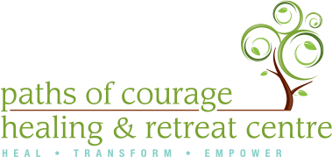](http://www.pathsofcourage.com/)

**Paths of Courage Program Assistant**

This position will be a FT contract 35 hours per week

The Sexual Assault Centre for Quinte & District is a feminist organization that provides non-judgemental, trauma informed support and information for all survivors of sexual violence in Hastings & Prince Edward Counties. We have an opening at our Residential Program in Prince Edward County. The successful candidate will bring passion, maturity and confidence and have prior work experience in this field. The successful candidate will be a self-starter, responsible and take pride in their work. They will work cooperatively and effectively with the current staff at Paths of Courage and SACQD.

**Program & Administration support including:**

* Facility maintenance as scheduled and administration support as required
* Correspondence via all communication modes (telephone, text, fax, email)
* Assist with Challenge Course operation
* Assist Paths facilitators as directed by SAC management
* Flexible to work dayshift and afternoon shifts a must
* Responsible for overseeing the evening workshops during all Residential Healing Program
* Completing/scheduling/organizing facility maintenance schedule
* All other tasks as assigned by SAC management

**Qualifications:**

* Post-secondary degree/diploma in Social Services or related field
* VAW and GBV sector knowledge and experience
* AR/AO knowledge and understanding
* Strong verbal and computer communication skills
* Ability to work independently and as part of a dynamic team
* MUST be able to work shift work (9am-4pm and 4pm-11pm)
* Valid driver’s Licence and insurance with the use of a vehicle is a must
* Current Police check
* Current CPR & First Aid is an asset
* Certified Belay or Level I is an asset
* Willing to maintain Level I Certification annually

**Please forward resume to Sally Fremr @** [**sallyf@sacqd.com**](mailto:sallyf@sacqd.com)